Name:- abhishek pundir ,

University rollno:- 2001008,

Student id :- 20711162;

Dehradun campus

Q1:-There is an organization A with multiple departments. Design a network for the HR department and the size of the department is 10 users. Also, show the communication between user number 1 and user number 5 of the network.

Ans.

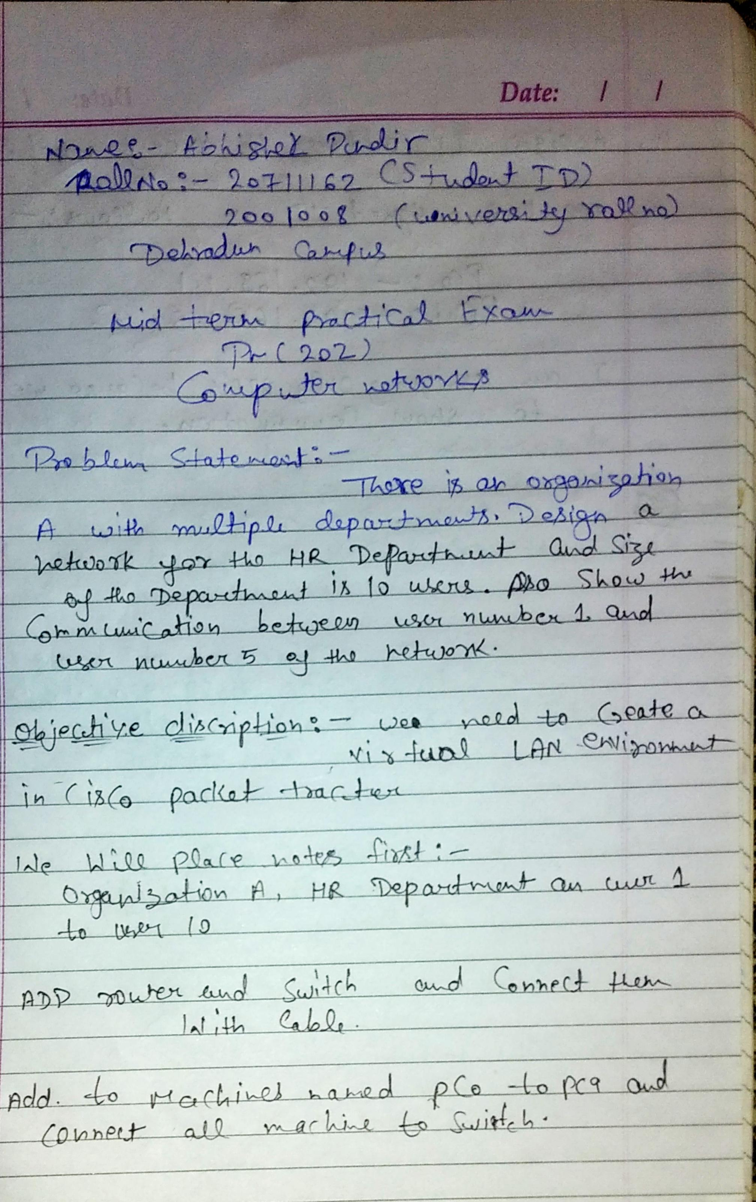

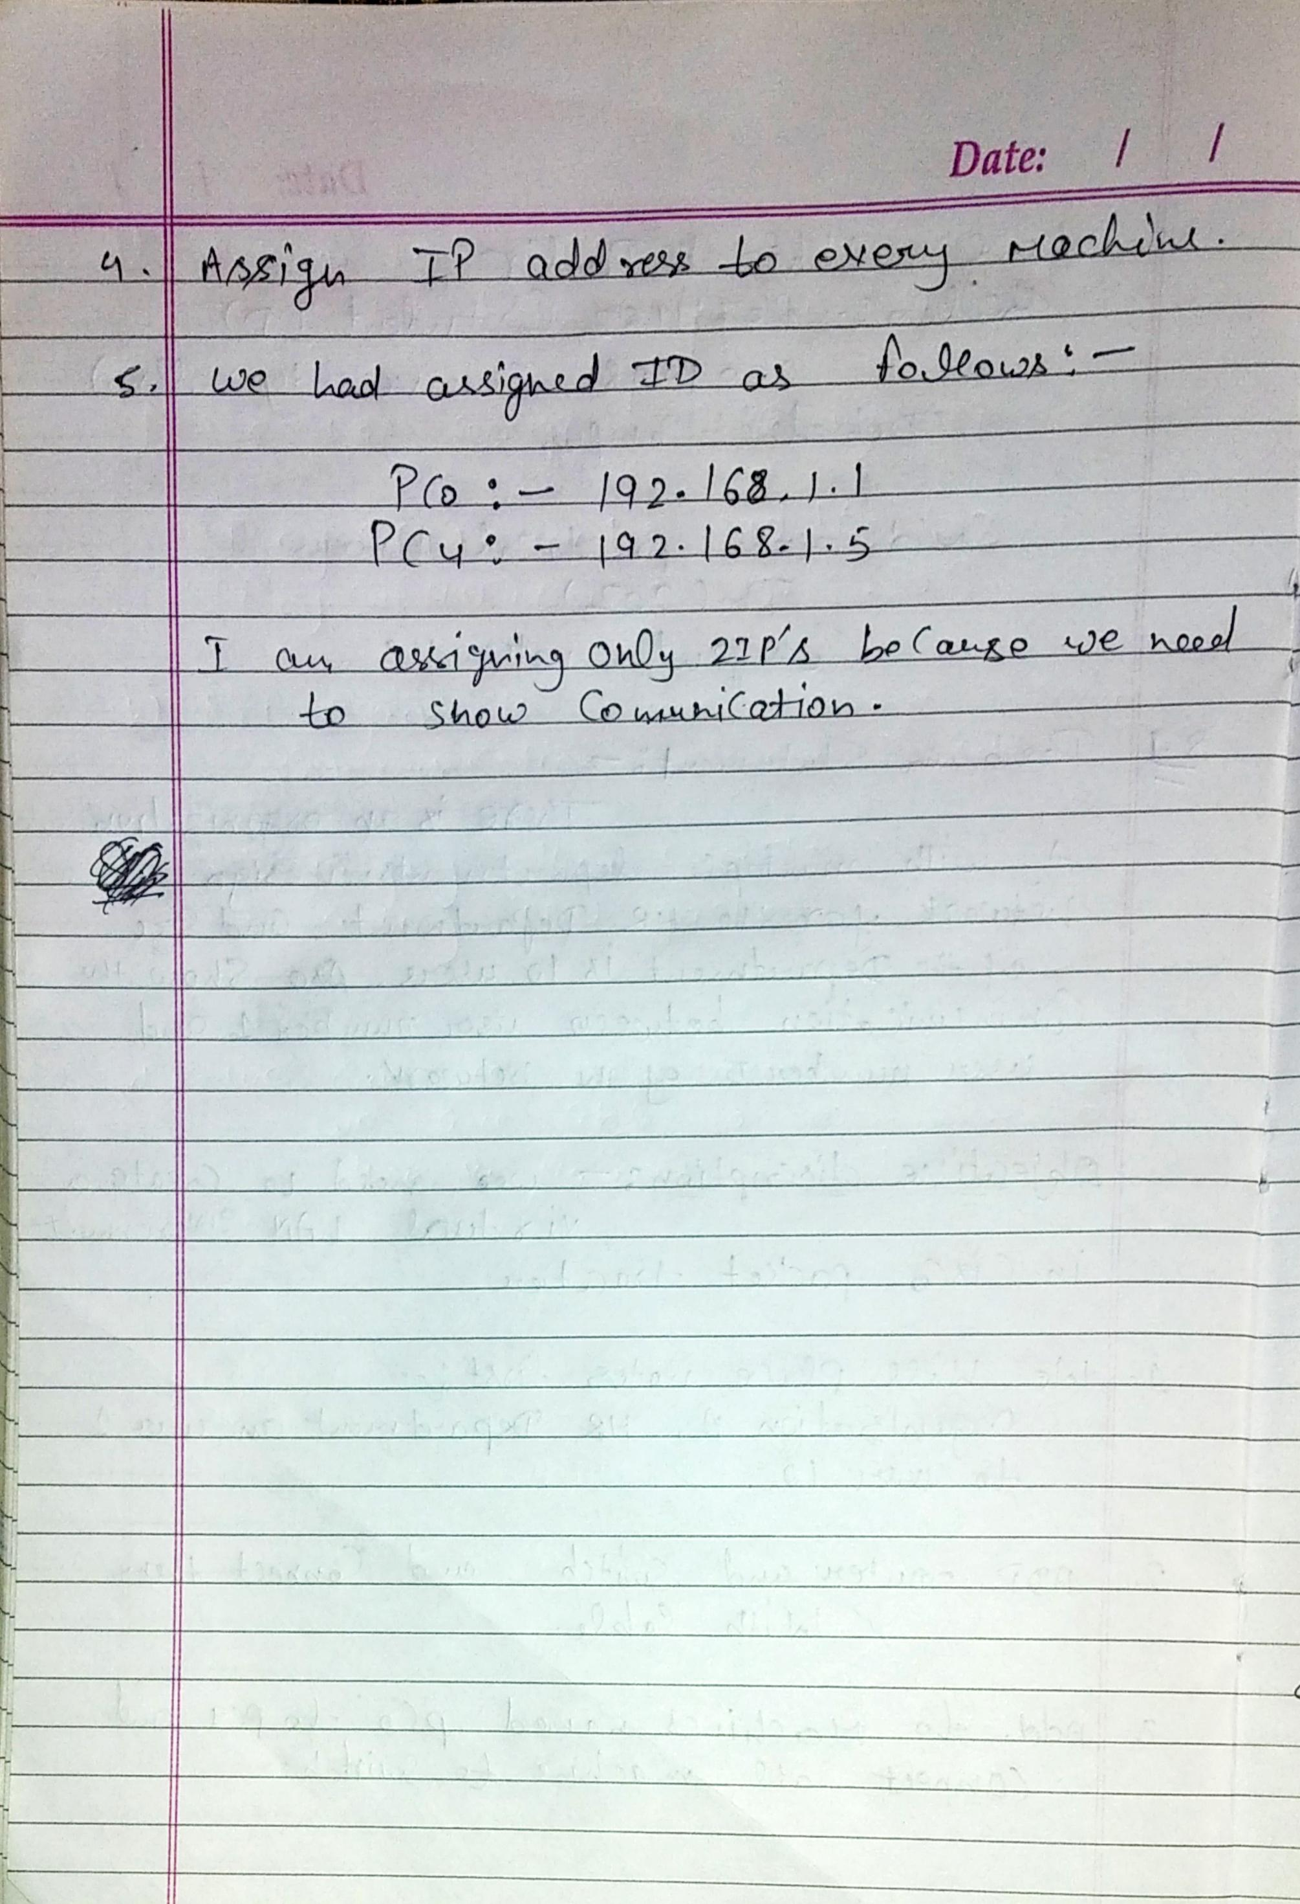

**Output Screenshots from Packet Tracer Q1**

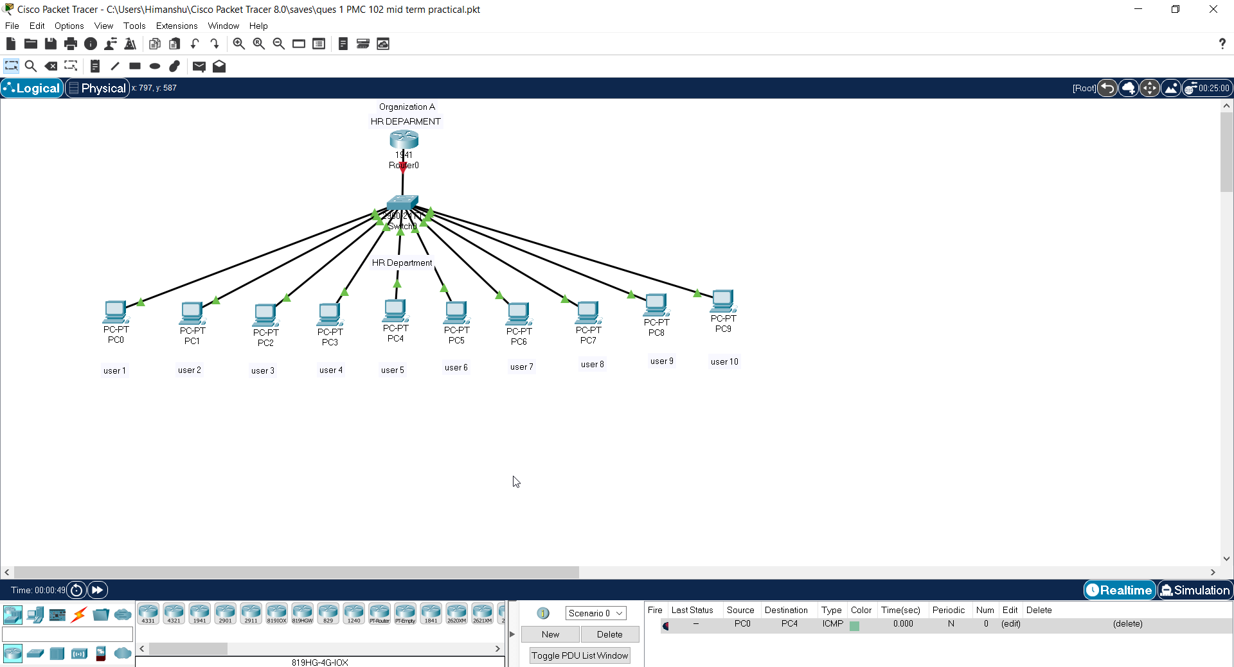

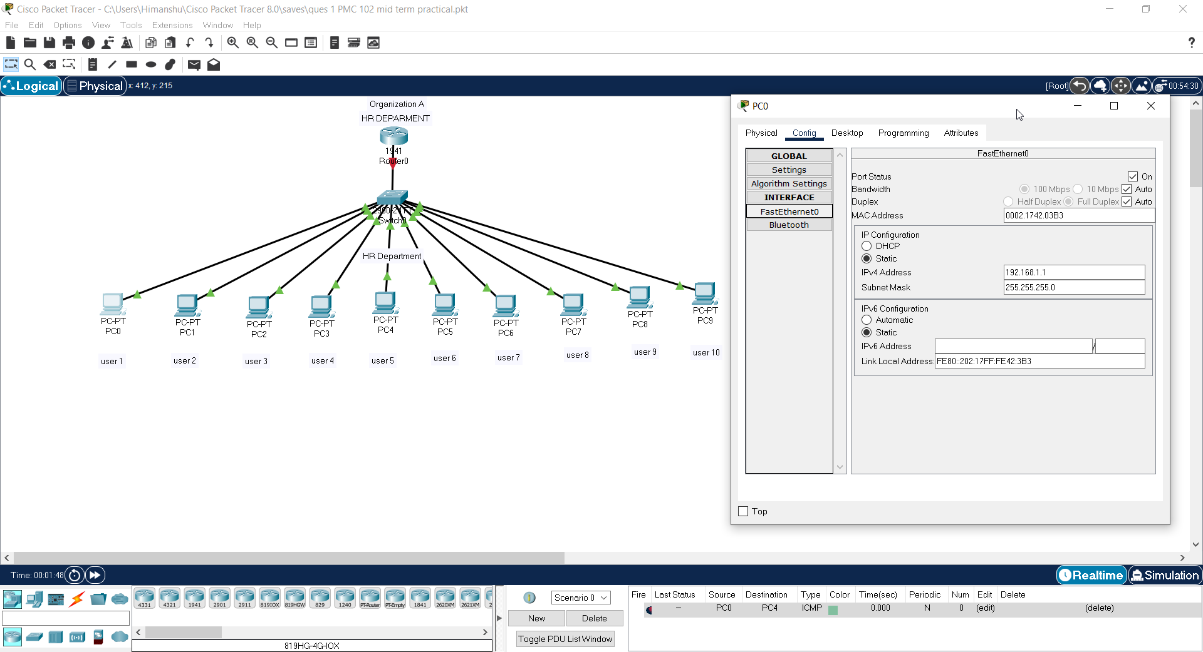

**IP assigned to User 1**

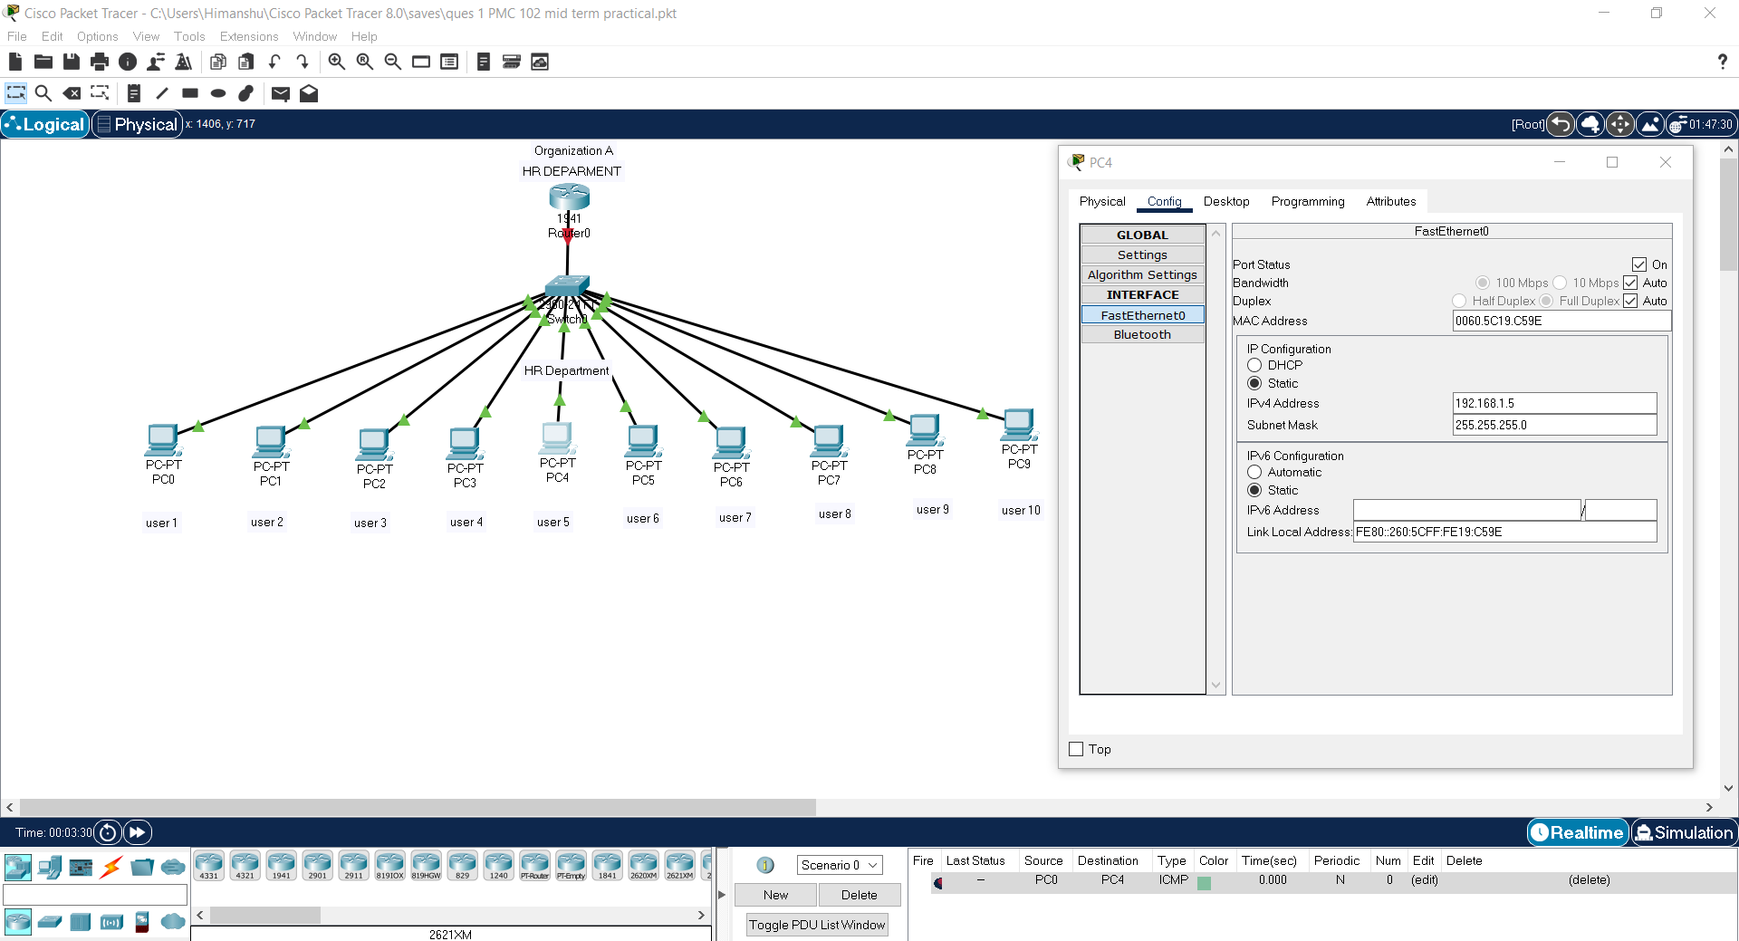

**IP Assigned to User 5**

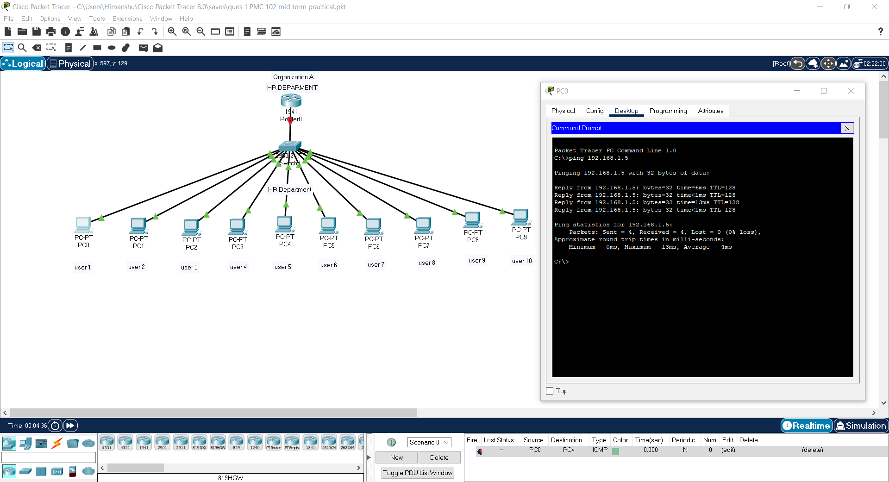

**Pinging User 1 to User 5. Successful**

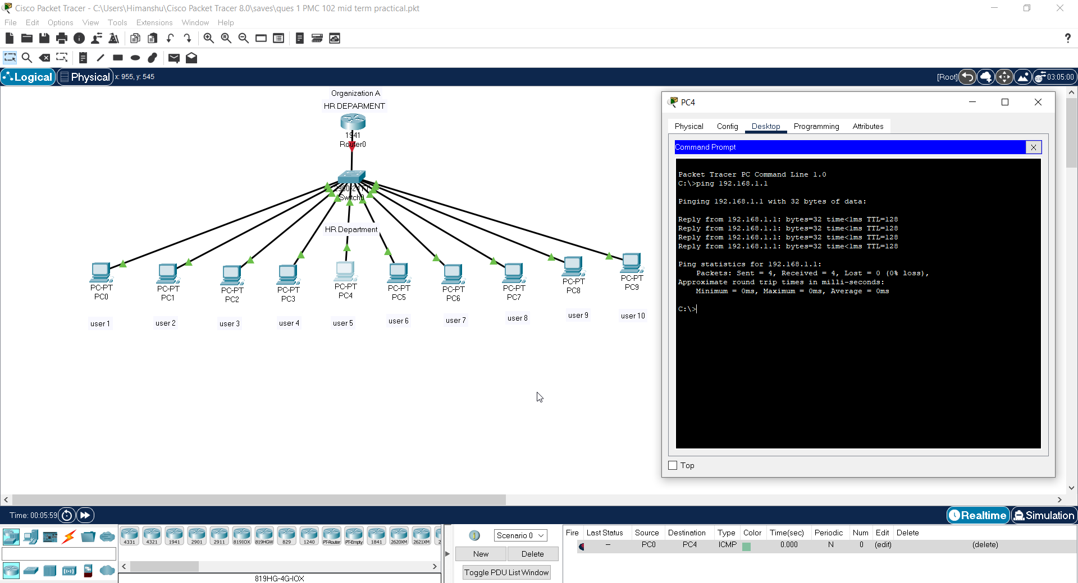

**Pinging User 5 to User 1. Successful**

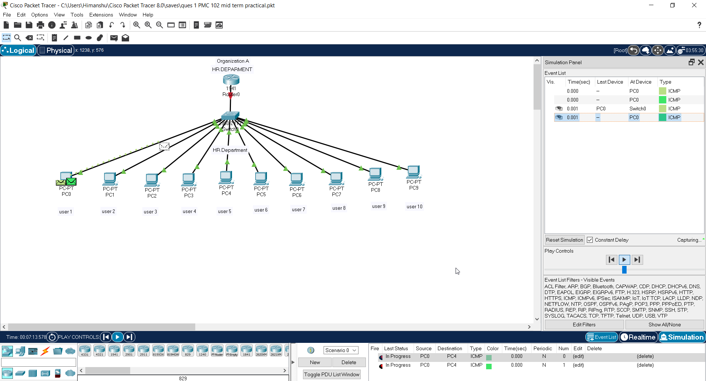

**Sending PDU from User 1 to User 5 In simulation Mode**

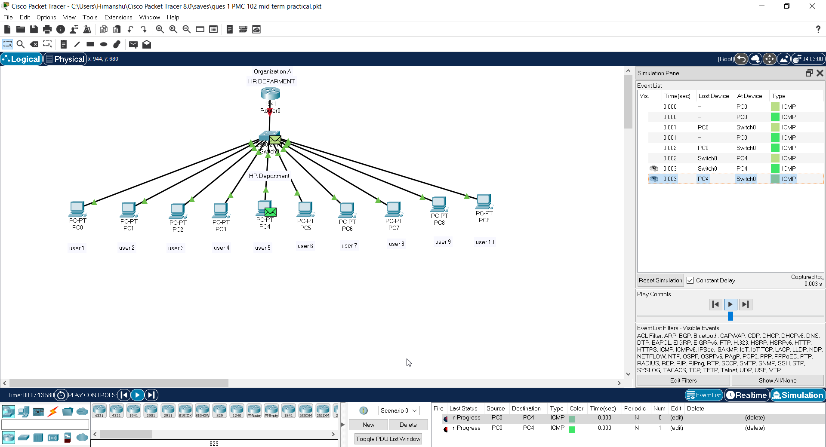

**Packet Received by User 5 which was sent from user 1**

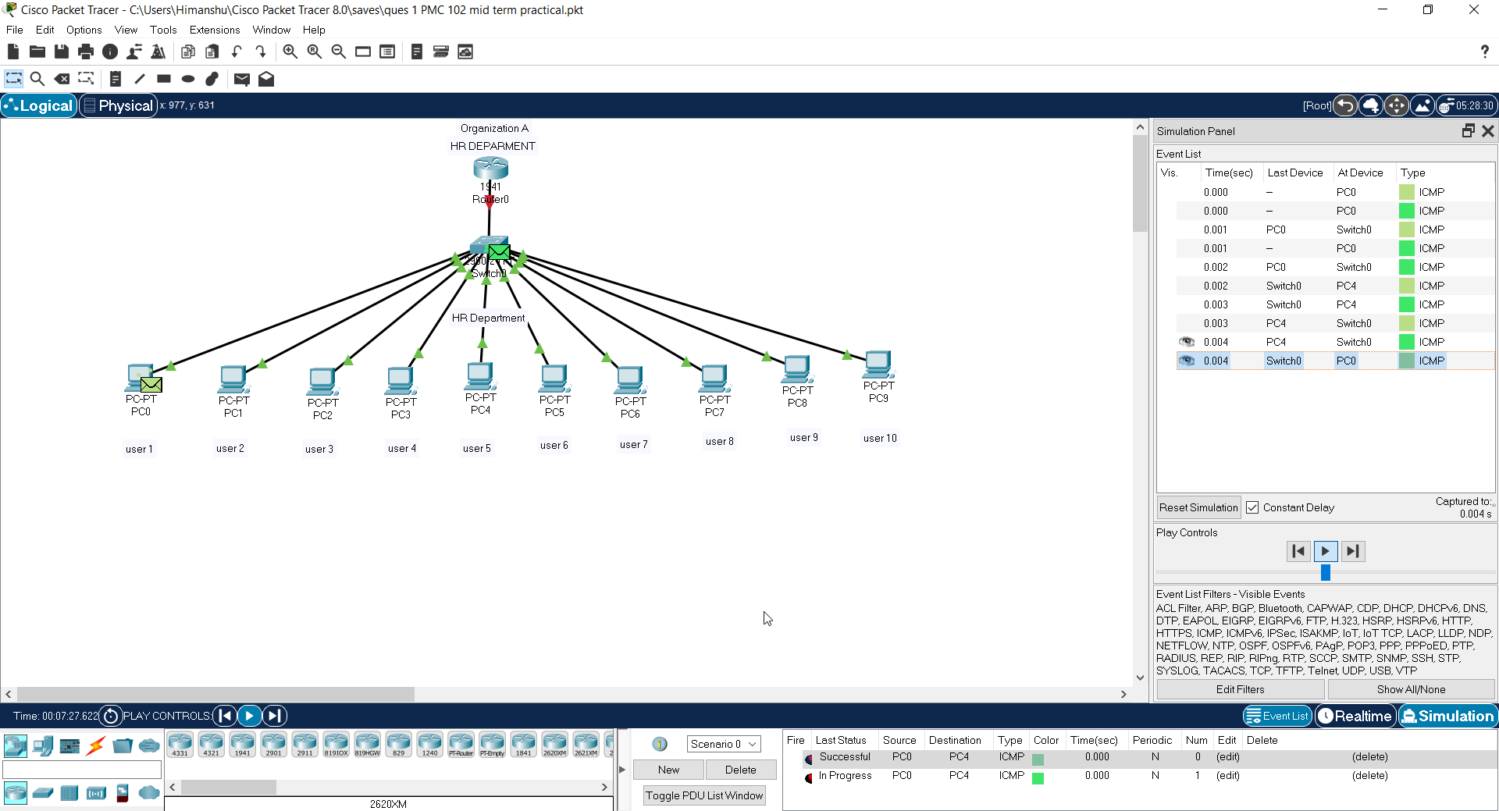

**Packet sent back to user 1 from user 5**

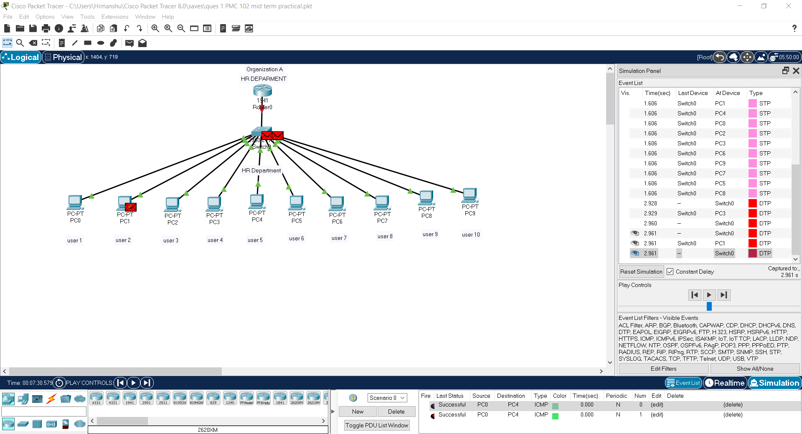

**Here we can see Successful Message at right bottom corner.**

**Hence Connection is established and working.**

Question 2

There are two organizations in a city named GEU and GEHU, design a network between the SOC department of GEU and GEHU. Also, show the communication between user number 1 of GEU and user number 2 of GEHU.

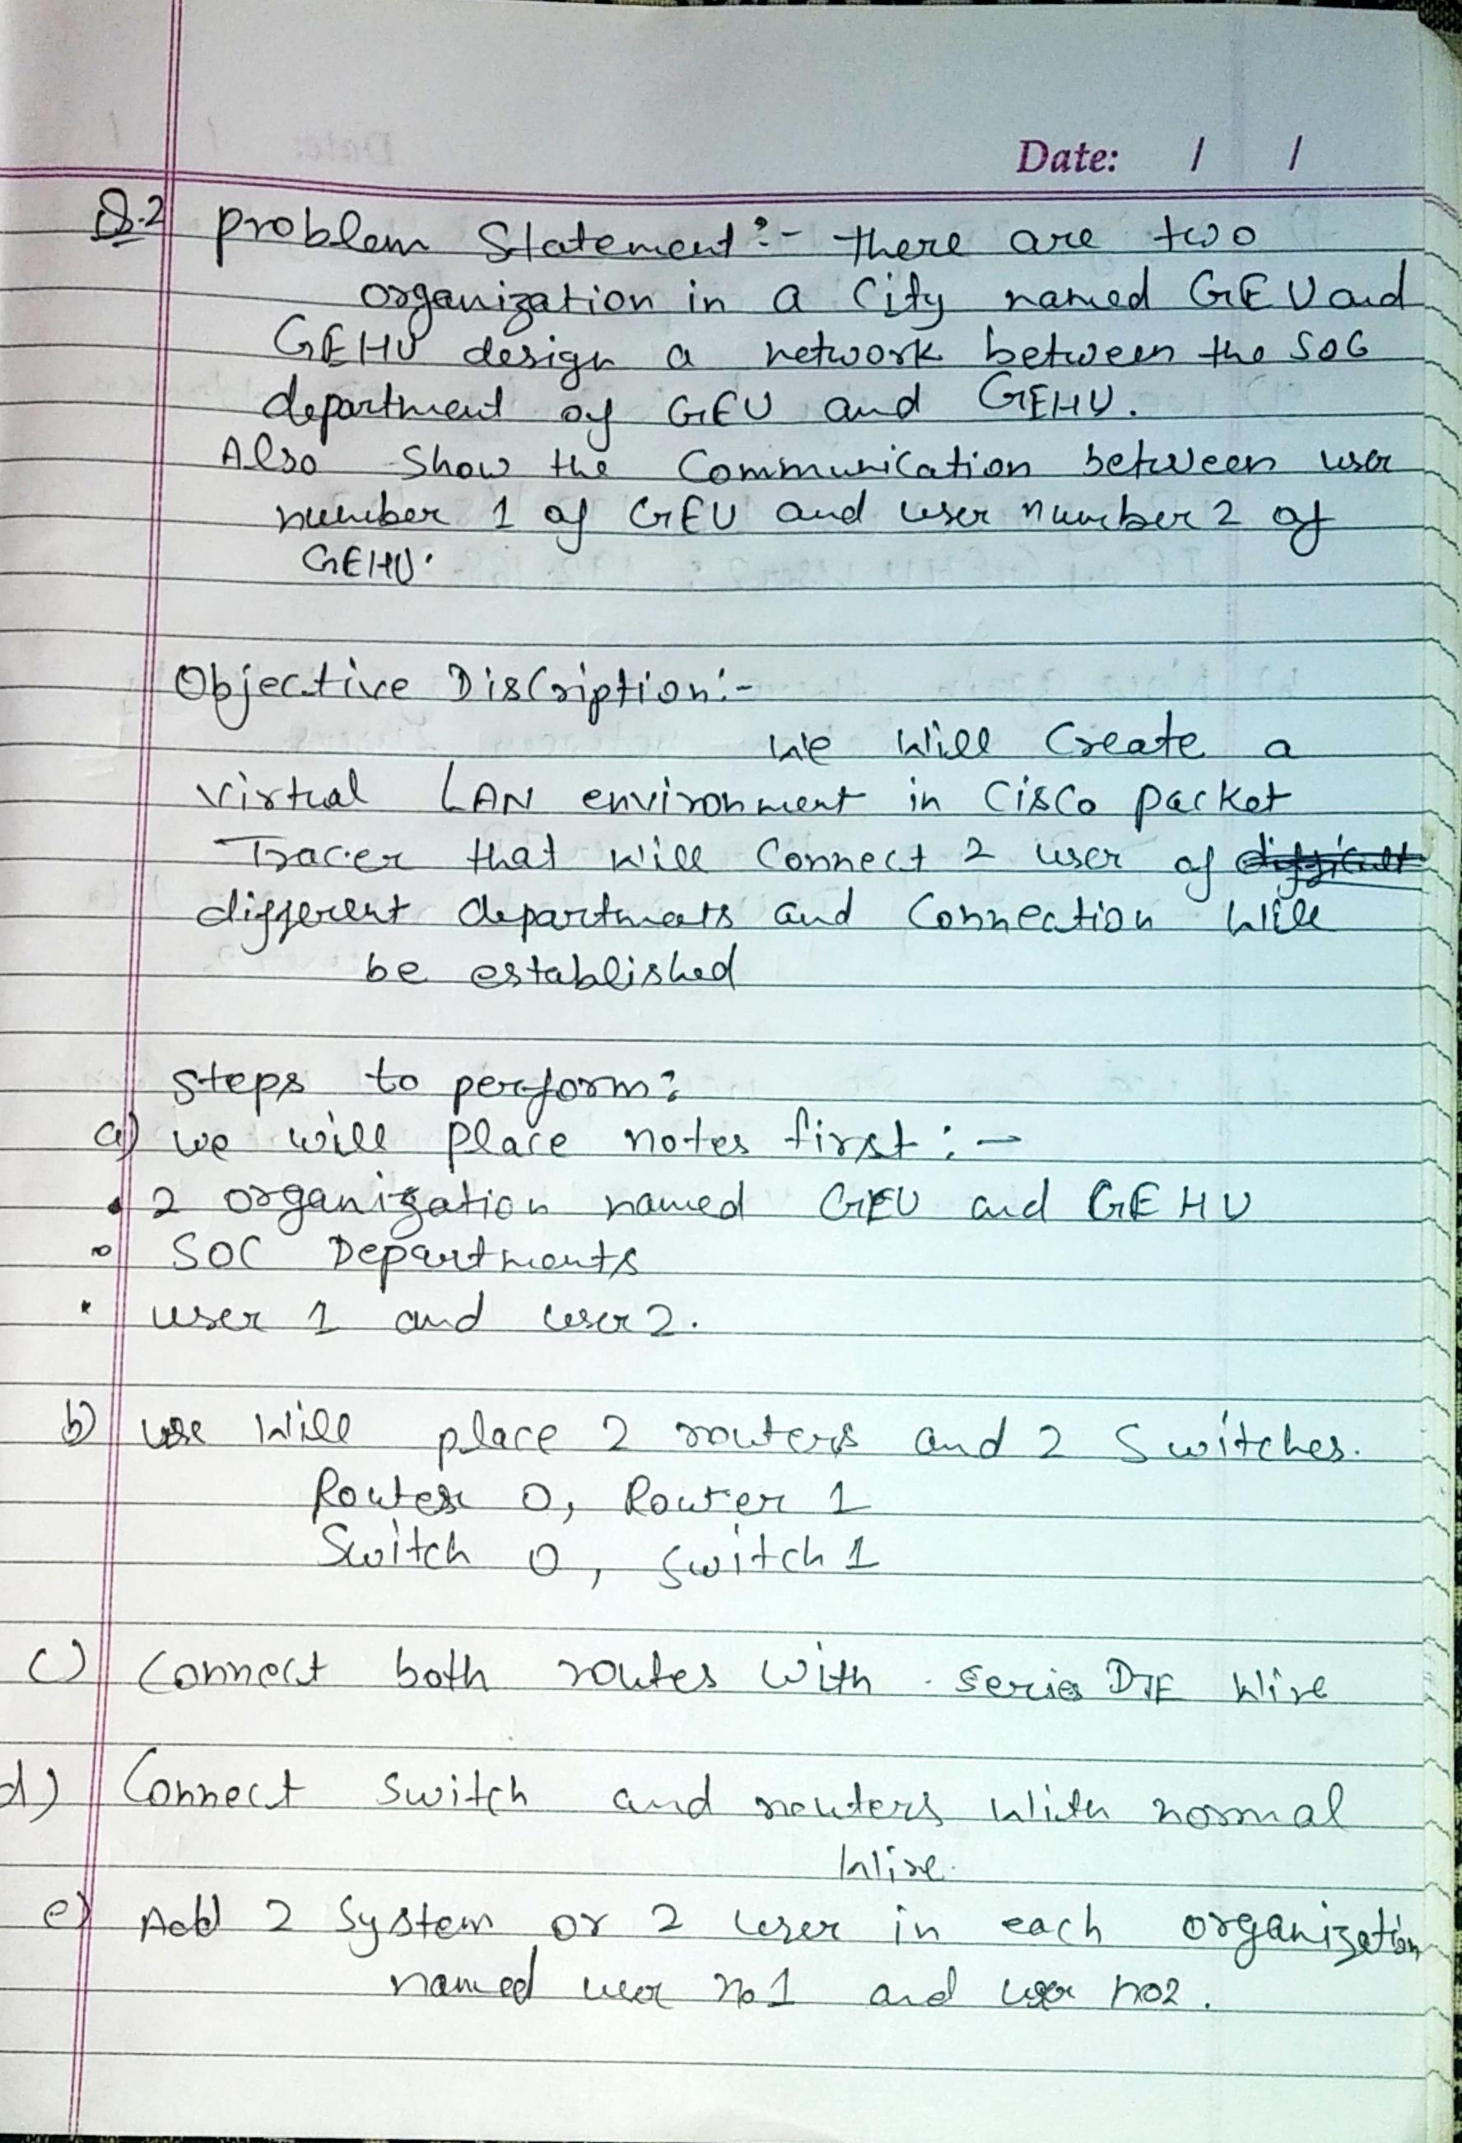

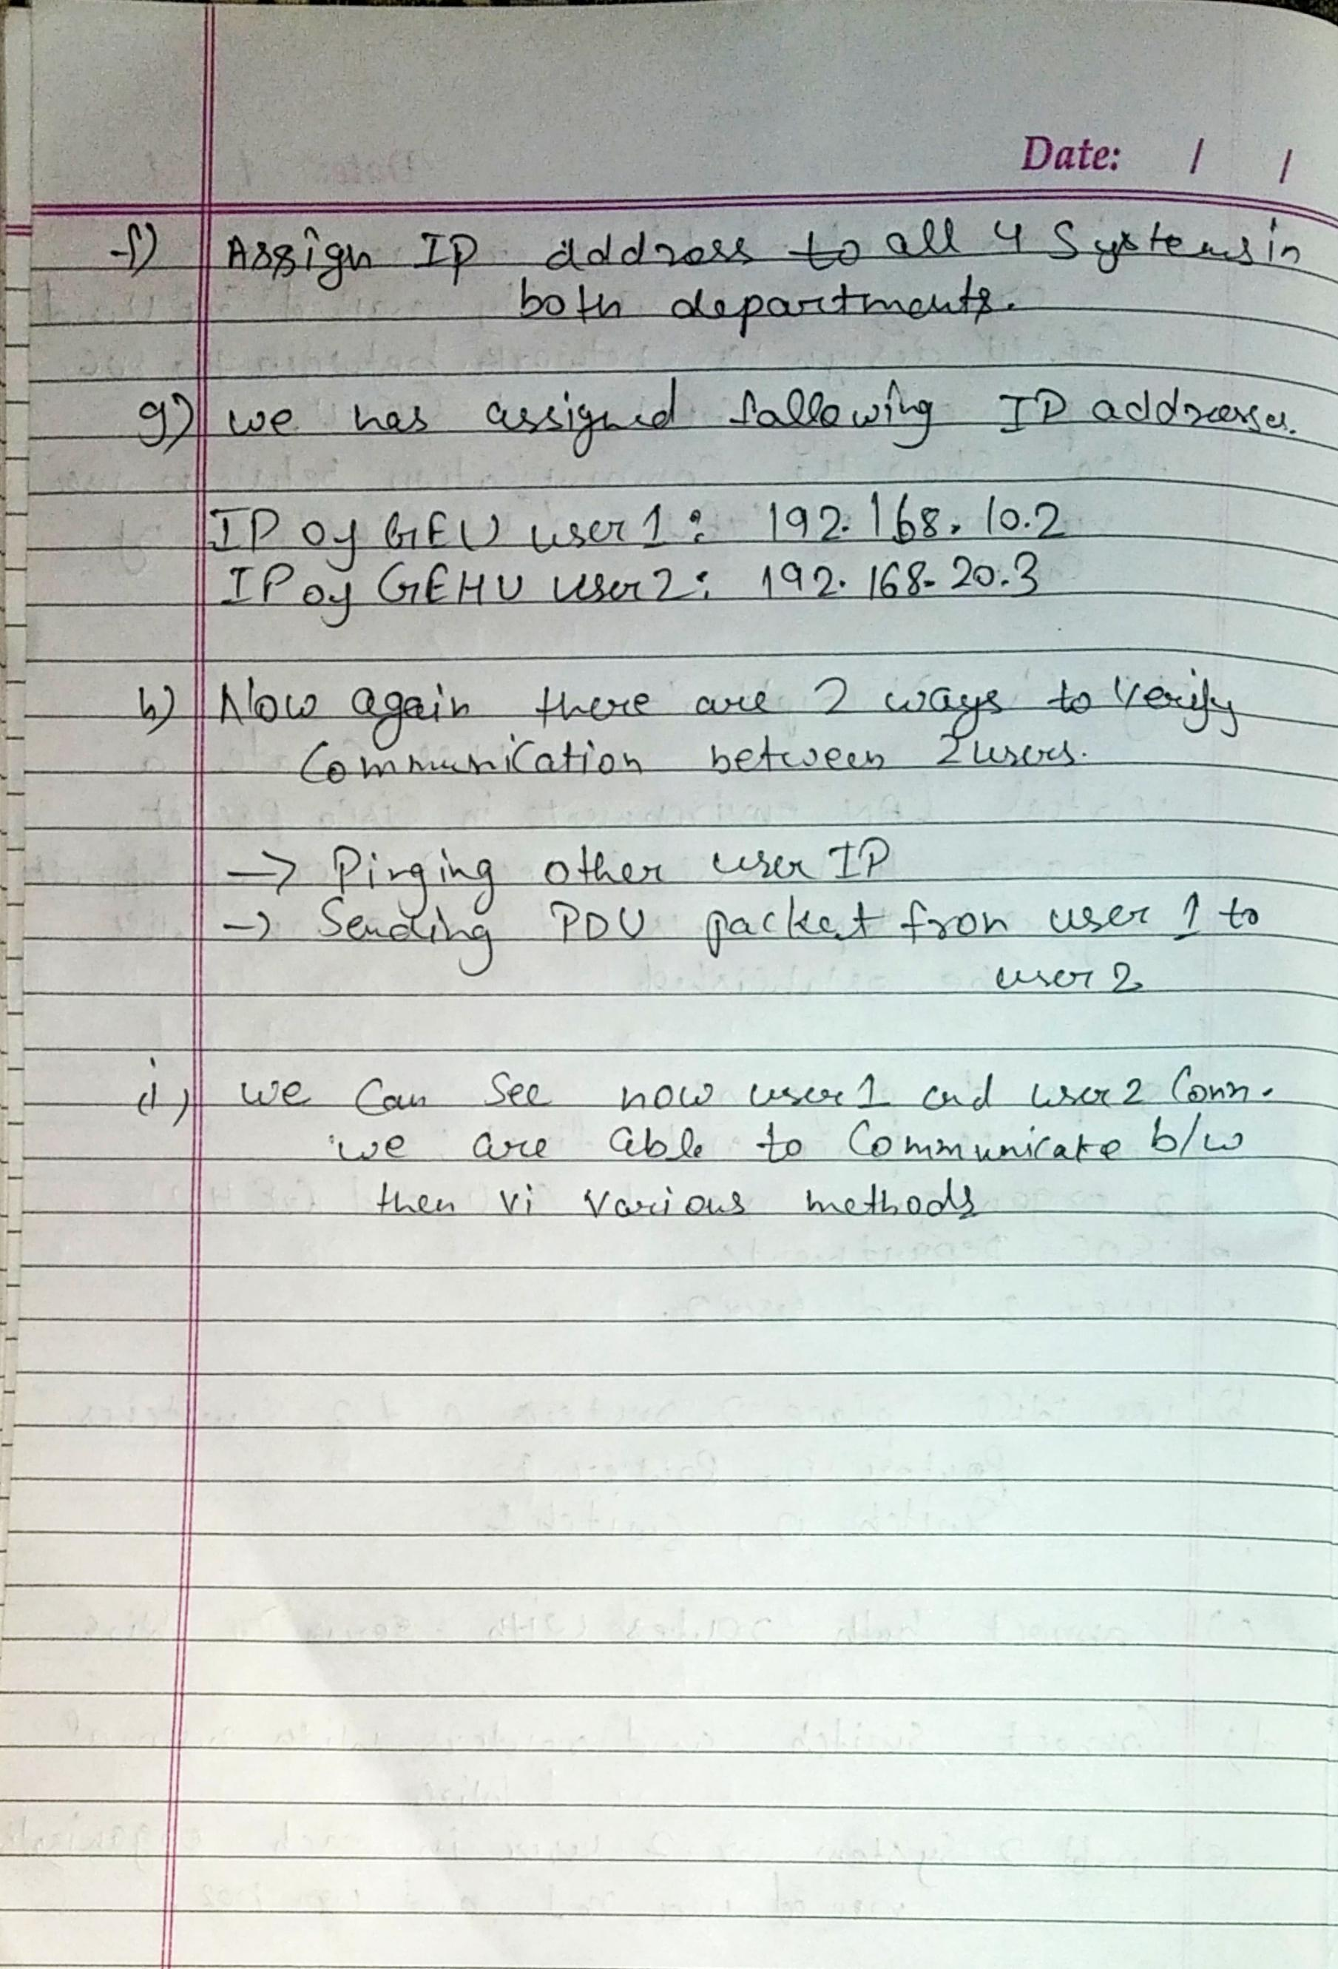

**Output Screenshots from Packet Tracer Q2**

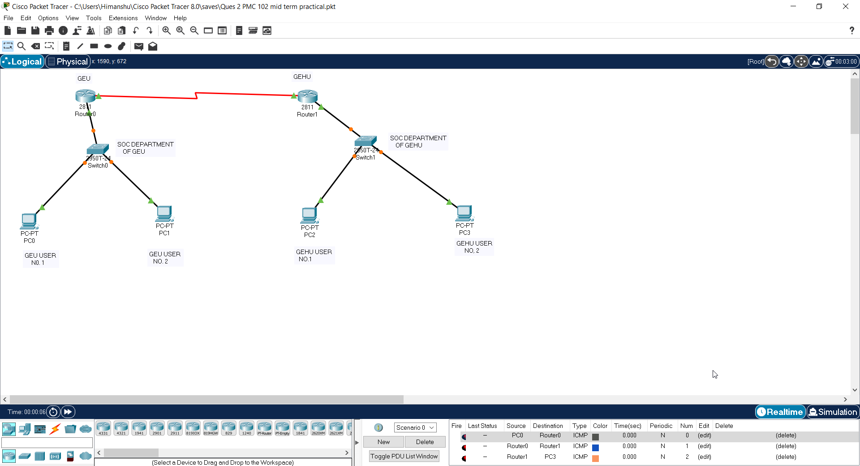

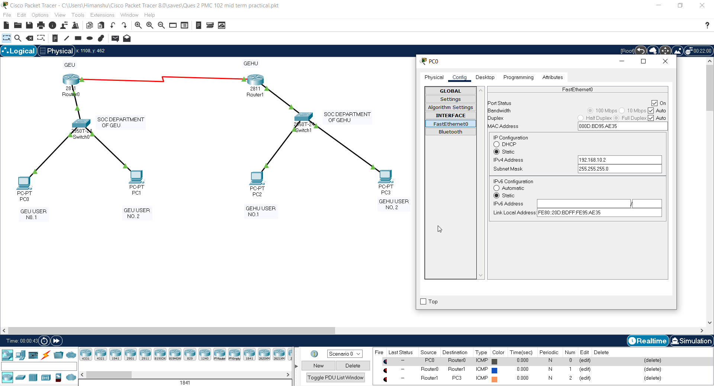

**IP assigned to User 1 of GEU. 192.168.10.2**

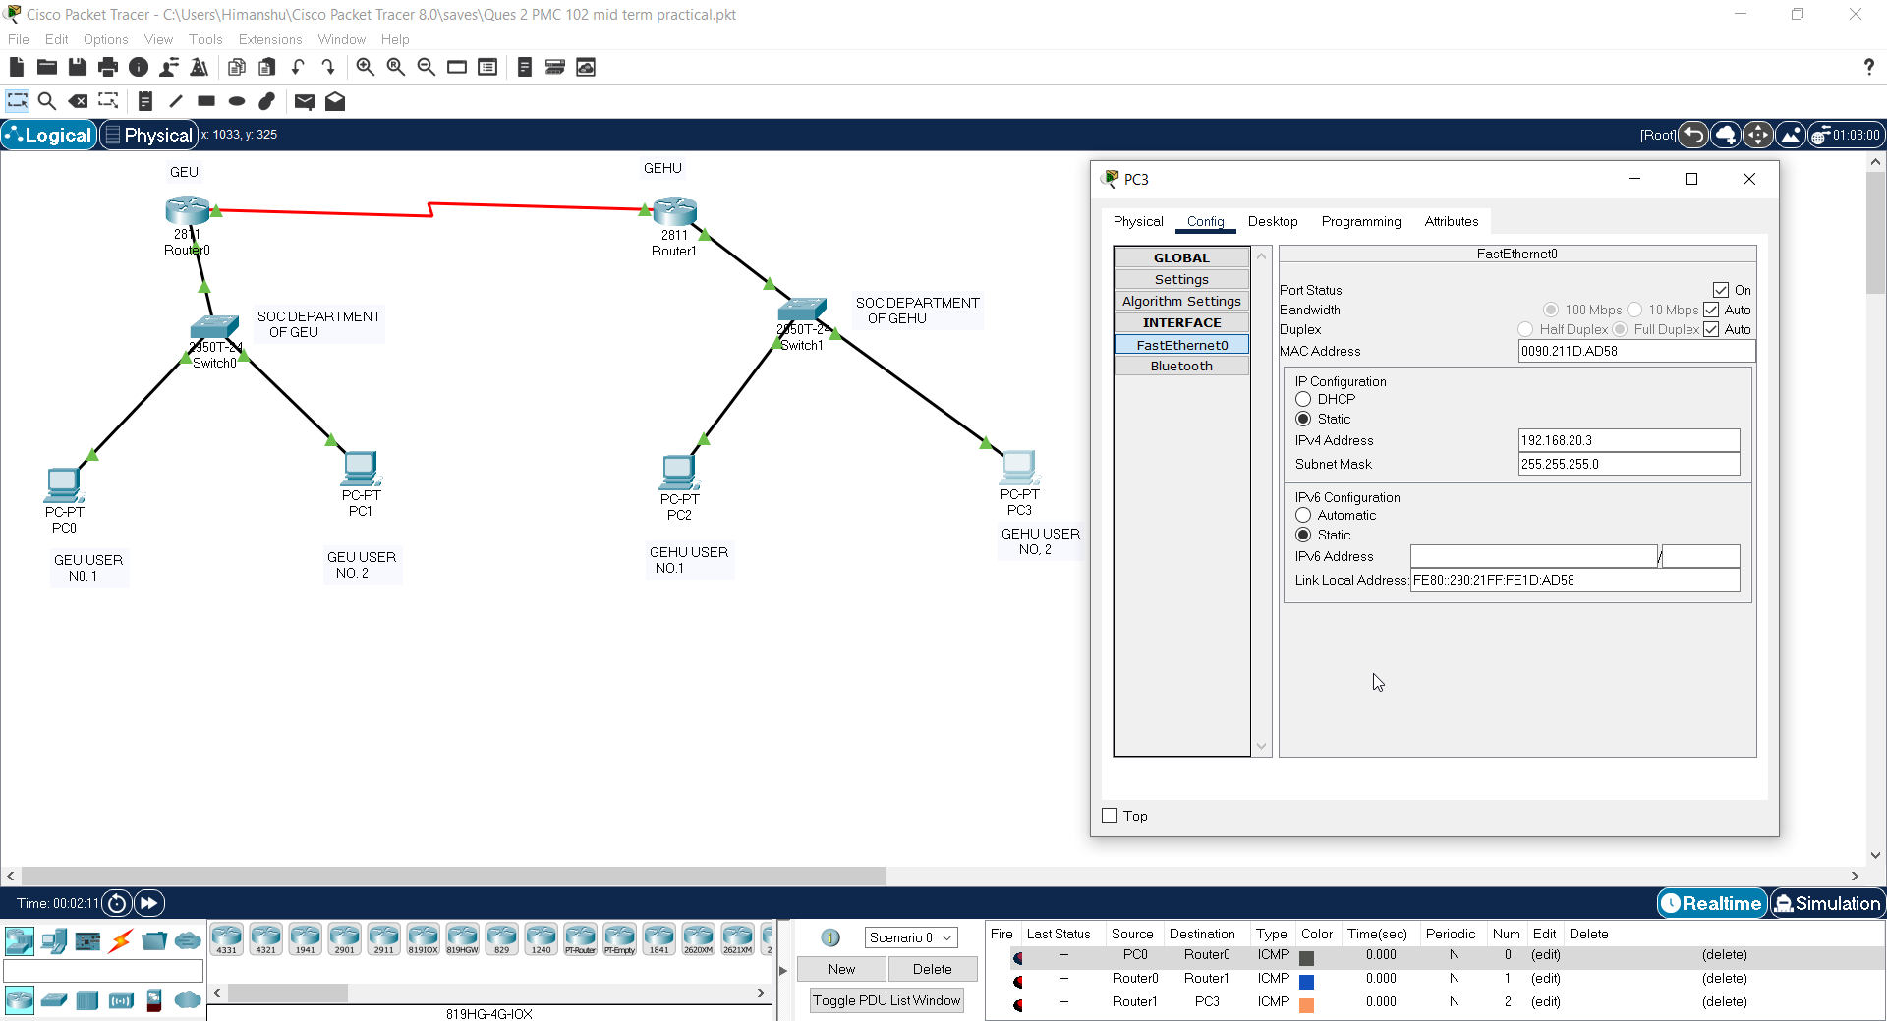

**IP assigned to User 2 of GEHU. 192.168.20.3**

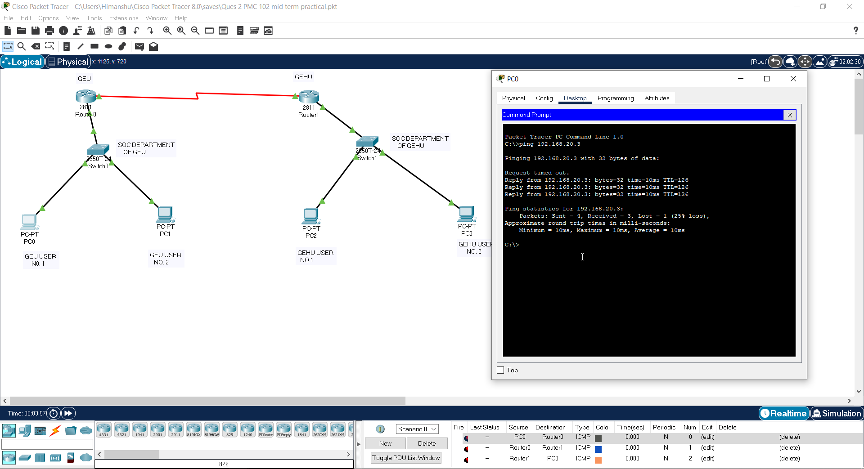

**Pinging User 2 of Gehu from User 1 of GEU**

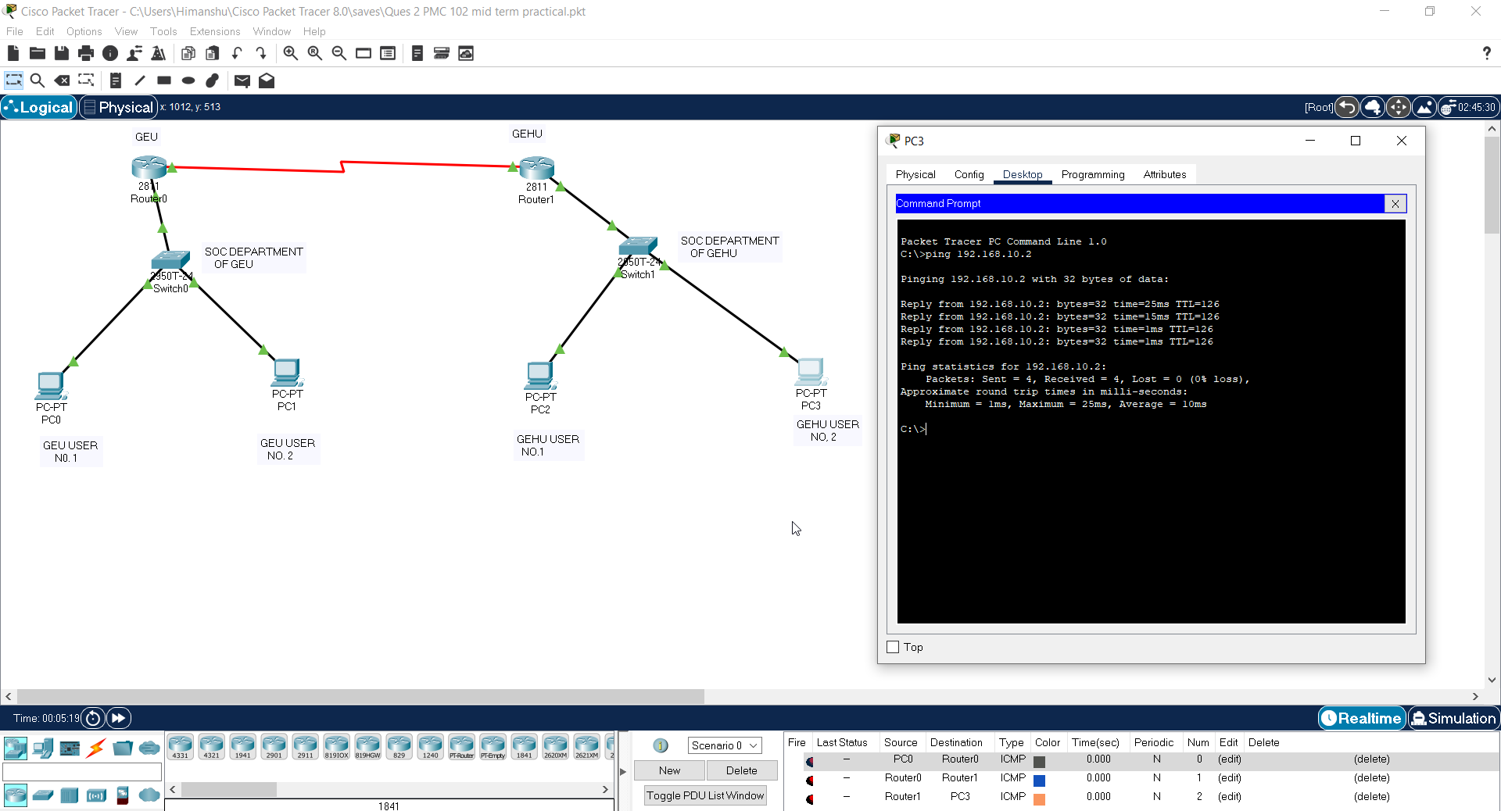

**Pinging user 1 of Geu from user 2 of GEHU**

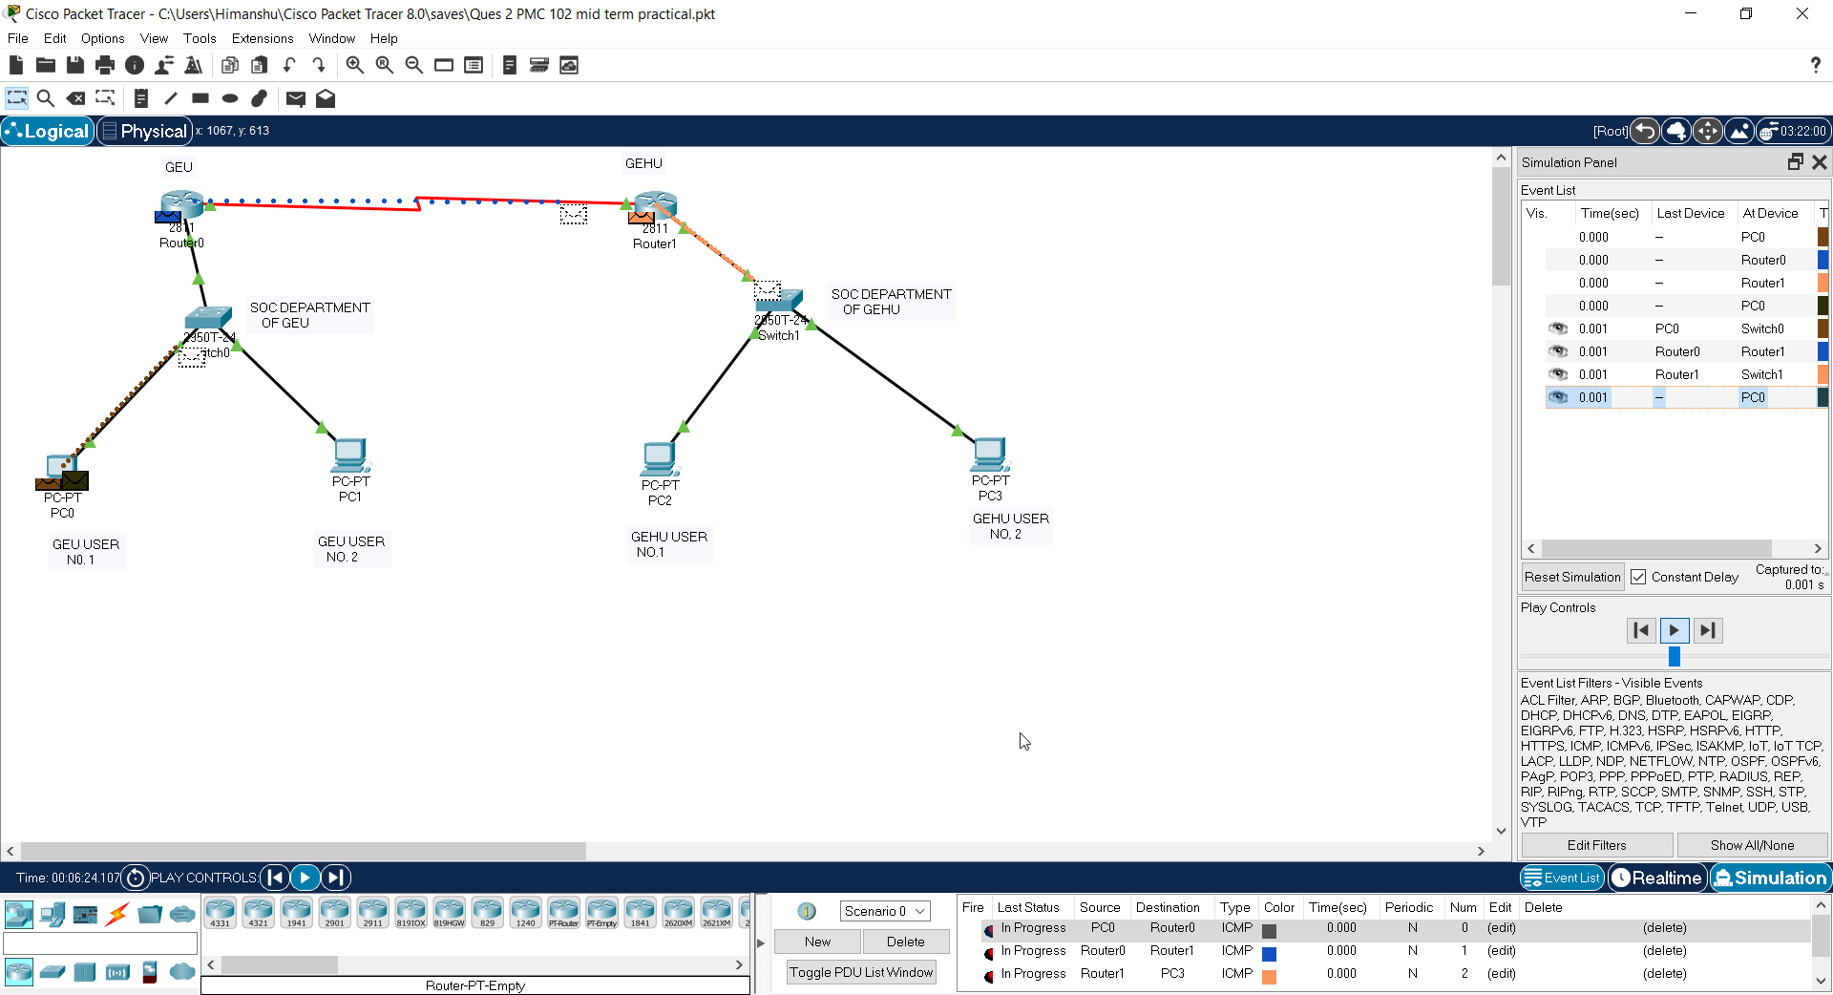

**PDU being sent to User 2 of GEHU from User 1 of GEU**

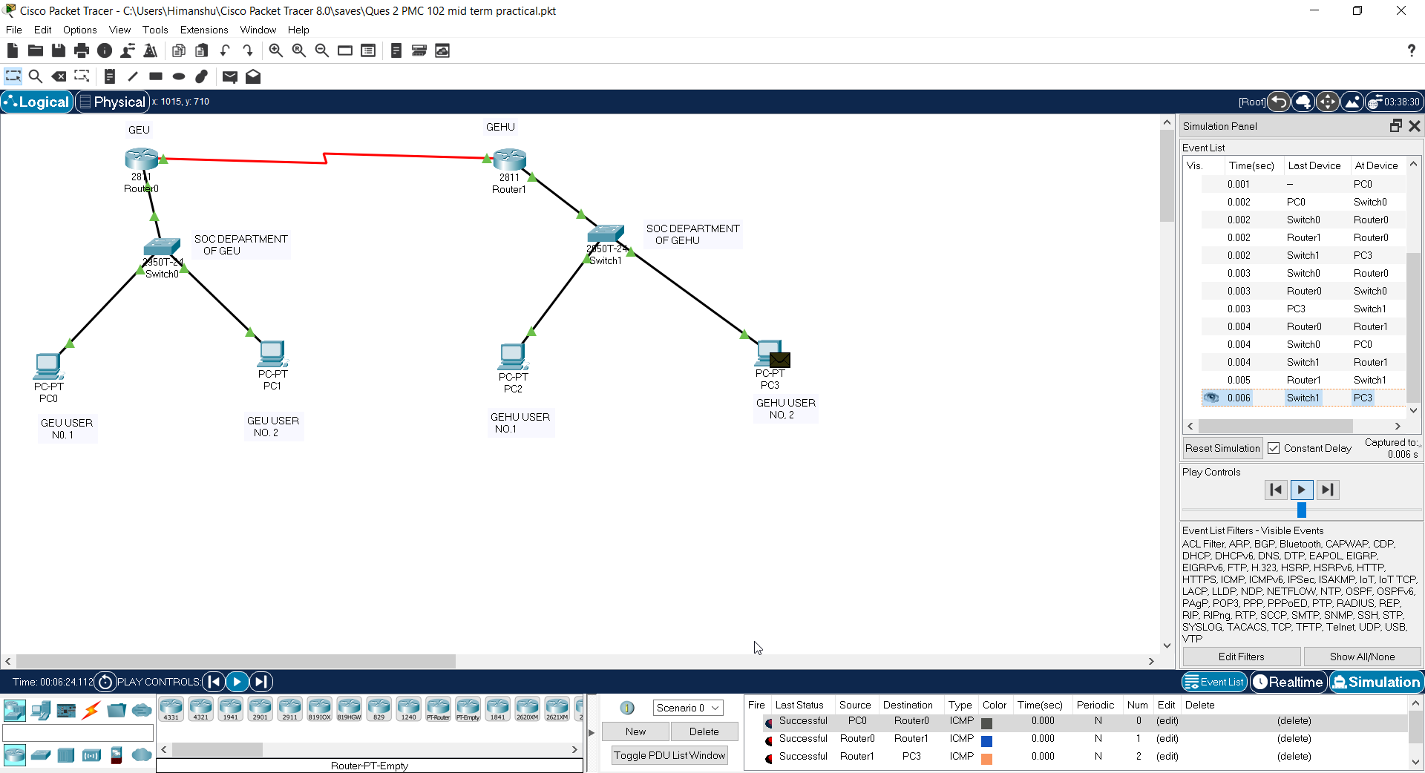

**PDU Received by User 2 of GEHU from User 1 of GEU**

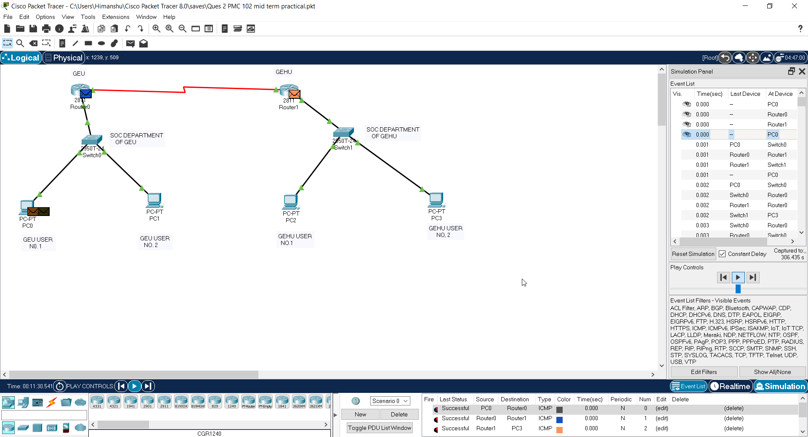

**PDU received back by user 1 of GEU from User 2 of GEHU**

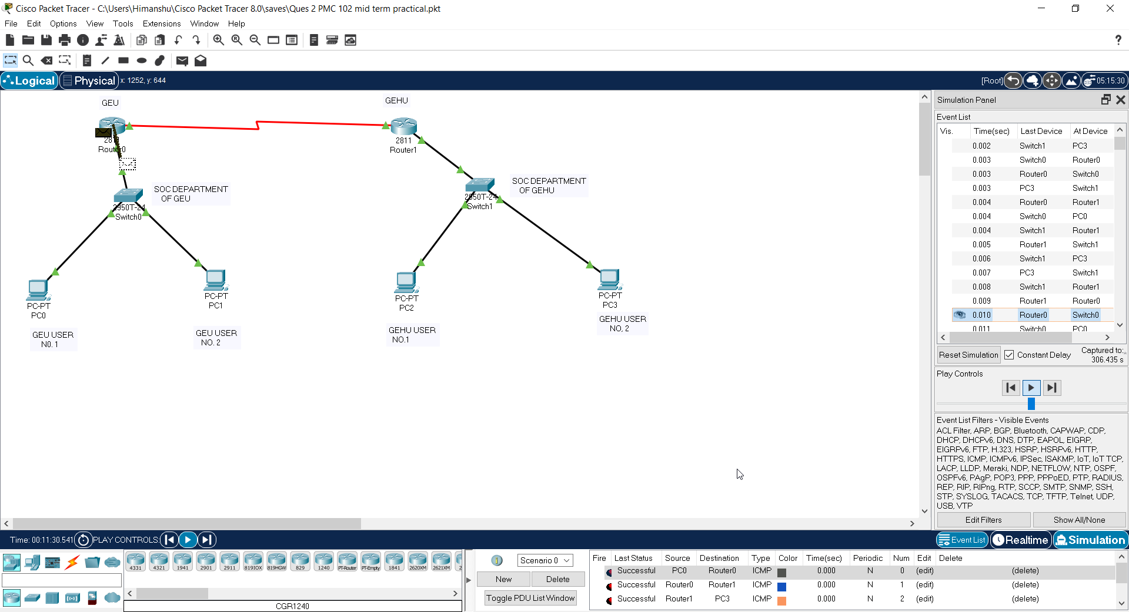

**Successfully established connection there from User 1 of GEU to user 2 of GEHU. Check Successful message at right bottom corner.**

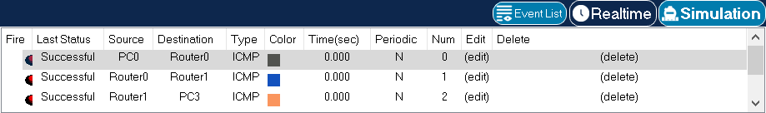

**PC 0 (GEU user 1) to PC 3 (GEHU user 2)**

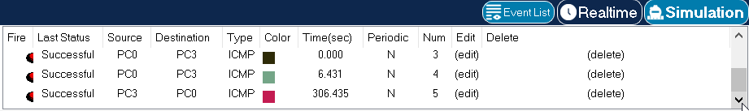

**PC 3 to PC0**

**Successfully connection established in both ways.**